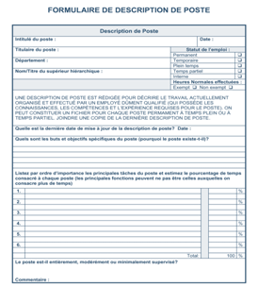
Élaboration d’une description de tâches
À partir d’un poste de bénévolat qui existe dans votre organisation, élaborez une description de poste en bonne et due forme à partir des outils offerts et de cette grille

Titre ________________________________________________________________________________________________
________________________________________________________________________________________________

Petit texte invitant sur l’organisation ou le projet
________________________________________________________________________________________________________________________________________________________________________________________________________________________________________________________________________________________________________________________________________________________________________________________________________________________________________________________________________________________________

But du poste
________________________________________________________________________________________________________________________________________________________________________________________________

Liste des tâches et des responsabilités
________________________________________________________________________________________________________________________________________________________________________________________________________________________________________________________________________________________________________________________________________________________________________________________________________________________________________________________________________________________________________________________________________________________________________________________________________________________________________________________________________________________________

Horaire, temps à consacrer ou engagement
________________________________________________________________________________________________________________________________________________________________________________________________________________________________________________________________________________________________

Aptitudes exigées (ou à développer)
- Compétences génériques : qualités de base nécessitées
- Compétences spécifiques : capacités, habiletés liées à la tâche
________________________________________________________________________________________________________________________________________________________________________________________________________________________________________________________________________________________________________________________________________________________________________________________________________________________________________________________________________________________________

Formation et supervision offerte
________________________________________________________________________________________________________________________________________________________________________________________________________________________________________________________________________________________________________________________________________________________________________________________________

Condition de bénévolat : Lieu, effort physique demandé, télé-bénévolat…
________________________________________________________________________________________________________________________________________________________________________________________________________________________________________________________________________________________________________________________________________________________________________________________________

Avantages : activités de reconnaissance, formation personnelle, activités d’échanges et de socialisation entre bénévoles
________________________________________________________________________________________________________________________________________________________________________________________________________________________________________________________________________________________________________________________________________________________________________________________________

Contacts et autres infos pertinentes
________________________________________________________________________________________________________________________________________________________________________________________________

